Software Requirements Specification
For
Attendance Using Face Recognition System

Table of Contents

1. Introduction 14
1.1 Purpose 14
1.2 Intended Audience and Reading Suggestions 14
1.3 Product Scope 14
1.4 References 14
2. Overall Description 15
2.1 Product Perspective 15
2.2 Product Functions 16
2.3 User Classes and Characteristics 16
2.4 Operating Environment 17
2.5 User Documentation 17
2.6 Assumptions and Constraints………… ……………………………………………………….17
3. System Features 18
3.1 Login 18
3.2 Attendance Marking …………………………………………………….…………………18
3.3 Data Entry Module…………………………… …………………………………………..19
4. Other Nonfunctional Requirements 19
4.1 Performance Requirements 19
4.2 Security Requirements 19
4.3 Software Quality Attributes 20

Introduction

Purpose
The purpose of the project is to automate the method of attendance in companies that can replace the old manual methods. The project will also reduce the errors that occur in the traditional (manual) attendance taking system.

Intended Audience and Reading Suggestions
This document is intended for, such as developers who follow the guidelines according to use case diagrams and develop the modules. Project managers use this SRS for checking project milestones and deadlines. Users use SRS to verify the functional requirements and approve the project according to mentioned criteria. Testers use SRS for testing purpose such as alpha testing, integration testing, etc. The project is also used by company employees. So these are the audience for the SRS and in this document product scope, purpose, project description and all the references mentioned which is useful for all the audience. Sequence of reading the document beginning with purpose and product scope then references from where we take some knowledge then overall description of project then interface requirements then system features and non-functional requirements.

Product Scope
Attendance using face recognition is an Automation System for company employees. This Automation System is a Standalone application intended to provide complete and relevant information to authorities about all employees working in company. This system will use face recognition to mark attendance of employees that will be more reliable than manual attendance system. The system will save time, resources, reduce the amount of work the administration has to do.

References
1) Biometrics. (n.d.). Retrieved from Wikipedia: https://en.wikipedia.org/wiki/Biometrics
2) eigenface. (n.d.). Retrieved from wikipedia: https://en.wikipedia.org/wiki/Eigenface
3) S. Thakur, J. K. (n.d.). Face Recognition using Principal Component Analysis and RBF Neural Networks . IJSSST, Vol. 10, No. 5 .

Overall Description

Product Perspective
The automation attendance software for companies is the replacement of the manual work of taking attendance which has some serious limitations such as:
- manual control
- not user friendly
- lots of paper work
The online automation attendance software for companies is developed for marking the attendance of company employees. It facilitates to access the attendance information of a employee for particular department or project. The attendance will be sorted by date.
The product does not use any kind of manual identification checking for each employee , it has the biometric face detection mechanism to process the identification of each employee.
To show the overall description of the product, we have four modules:
- Identification module
- Display module
- Biometric module
- Processing module

The identification module will perform the identification for each employee using the biometric mechanism for face detection .The admin can login using his id and password. If it matches then it will return the display screen otherwise an error message will be shown.
After identification the next module is the display module which will show the display screen corresponding to the user’s requirement.
In the biometric module, the employee will be recognized through face detection. If the employee’s faces matches with the one stored in the database , only then he will be allowed to proceed further otherwise an error message will be displayed.
Next after display screen user will be shifted to the processing module which will perform the required processing as it is selected by the user in display module and can perform the work, like if he is the employee then he can mark the attendance, if user is the admin then he can perform all the updation , deletion or insertion work for new or existing users.
In addition to the four modules, a Central database server will be used in order to read/write data onto the repository.

Product Functions

It must be able to perform Identification of admin by using login id and password and identification of each employee by using face detection
- Employee: whenever employee login is identified it will direct them to the corresponding pages such as mark attendance.
- Admin: whenever admin login is identified it will direct them to their corresponding pages such as update the information of employee, add new employee, view attendance of employees.

- The admin must be able to update, delete and insert information regarding the employees. The employee can also update the information.
- The admin can view the attendance of all the employees of a particular department and project and within a specific time period. The employee can view his/her attendance.
- Only authorized users are allowed to login. The authorized users are the administrator, employees.
- If invalid user name or password is given the system should inform the user.
- If unauthorized users try to access then it should not allow the user to work on the system.
- In “mark attendance” if the employee provides the requested information, the employee will mark the attendance and an appropriate message is displayed.

2.3 User Classes and Characteristics
In our system we have only two user classes which are as:
- Admin
- Employees
From above listed category of user we can see that all are from technical background or we can say that they have some knowledge of computer uses. Each user will use the product for different purpose. Thus while designing the software one can assume that each user type has the following characteristics:
- The user is computer-literate and has little or no difficulty in using this product.

- In order to use the biometric in this software it is not required that a user be aware of the internal working of a biometric but he/she is expected to know what happens when the user sits in front of the webcam.

2.4 Operating Environment
- Front end – C# .net
- Operating System – Windows XP/Vista/7/8
- Back end – Microsoft Office Access
- Hardware-Webcam

2.5 User Documentation

This software provides security. The login form prevents the system from being misused by unauthorized users. Only an authorized operator will be granted rights to modify as per requirements. The user should know the programming language very well that is used to develop software.

2.6 Assumptions and constraints
The following list presents the constraints, assumptions, dependencies or guidelines that are imposed upon implementation of the attendance software:
Assumptions:
- We assume that the Office personnel do all the data entry based on the correct values obtained from forms and registers. Users with administrator access should be careful in deleting or modifying any information knowingly or unknowingly which will lead to inconsistency of the database.
- The product must have a user friendly interface that is simple enough for all types of users to understand.
- A general knowledge of basic computer skills and of basic working of webcam based system is required to use the product.
- Response time for loading the software and for processing a request will be no longer than five seconds.

Constraints:

- The central database server should be updated regularly.
- The face recognition will depend upon the strength of the algorithm and various angles of face detection.
- The webcam should operate successfully.

3. System Features
3.1 Login
3.1.1 Description and Priority
The login form is used by all the users. This module has the highest priority when compared to all the other modules. This model allows the admin to enter his username and password in order to make use of the software. The biometric face detection will be used for the identification of employees.
3.1.2 Stimulus/Response Sequences
This module has text boxes where the user can enter his username name and password. If the necessary information is not provided or if invalid inputs are given by the user then the system will pop a message box.
3.1.3 Functional Requirements

Only authorized users are allowed to login. The authorized users are the administrator, employees. If invalid user name or password is given the system should inform the user. If unauthorized users try to access then it should not allow the user to work on the
system.

3.2 Attendance marking

3.2.1 Description and Priority

Employees will mark the attendance by using face recognition and this feature has higher priority because this is the most essential feature of the product.

3.2.2 Stimulus/Response Sequences
Once the employee provides the requested information, the following sub-flow is executed.
• “mark attendance” sub flow

3.2.3 Functional Requirements
In “mark attendance” once the employee provides the requested information, the employee will mark the attendance and an appropriate message is displayed.

3.3 Data Entry module
3.3.1Description and Priority
This module is used by admin who is responsible for entering the details of a employee . The module requests that the admin specify the function he/she would like to perform (either add an employee, update an employee, or delete an employee details).

3.3.2 Stimulus/Response Sequences
Once the admin provides the requested information, the following sub-flows is executed.

- employee update(add an employee, delete an employee, update an employee)
In “Add an employee” once the admin provides the requested information, the employee is added to the system and an appropriate message is displayed.
In “Update an employee” once the admin updates the necessary information, the system updates the employee record with the updated information.
In “Delete an employee” once the admin deletes the record, the system prompts the user to confirm the deletion of the employee.

4. Other Nonfunctional Requirements

4.1 Performance Requirements
The system should be available 365/24/7 days, the performance should not be degraded.

4.2 Security Requirements
The security of admin is provided with login id and password and there is use of biometric for each employee so the account of one employee can’t get hacked by someone other.

4.3 Software Quality Attributes
- Consistent uptime
This system will be able to stay up and running at least 98% of the time. Any downtime would be due to maintenance or upgrades. This downtime also includes any potential failures/crashes.

- Familiar Interface
The new system will have an interface that shares some of the feel of the old system so that users who are familiar with the old system will not have trouble adjusting to the new system.

- Portability
The system will be easily executed on different software/hardware platform with minimum changes in components.

- Testability
The system will be easy to test with the help of test cases described early during design phase.

Chapter-3. Design Documents

3.1 Software Architecture

Data Flow architecture:

Fig.9

Client-Server architecture:

Fig.10

  - UID (Project Snapshots)

Home Page

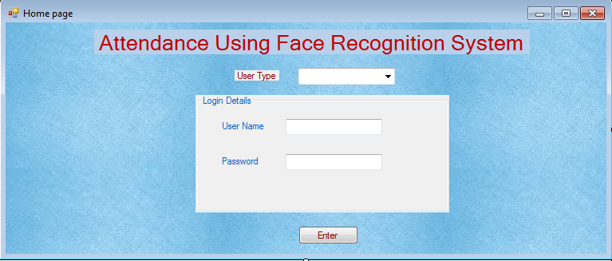

Fig.11

Main Page

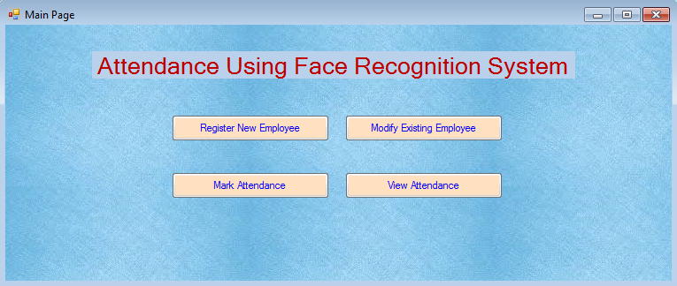
Fig.12

Registration Page

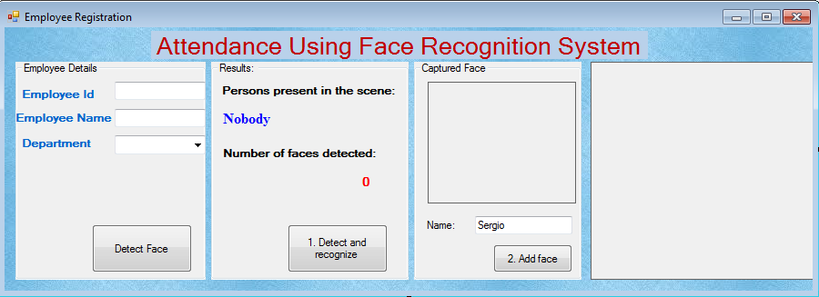

Fig.13

Employee Modification Page

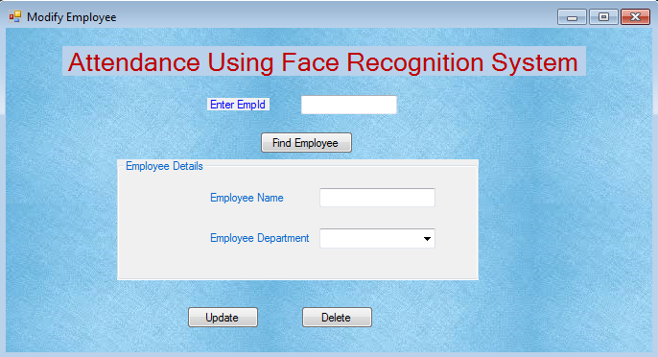

Fig.15

Mark Attendance Page

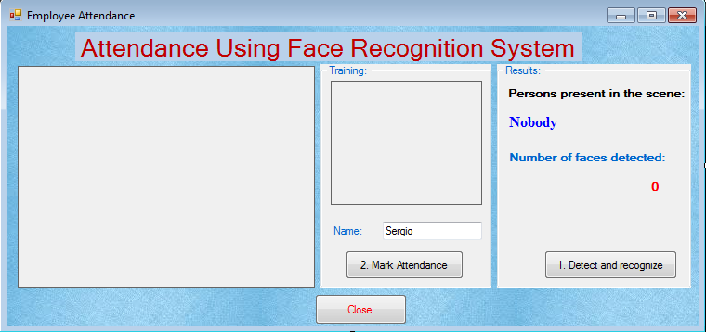

Fig.16

View Attendance Page

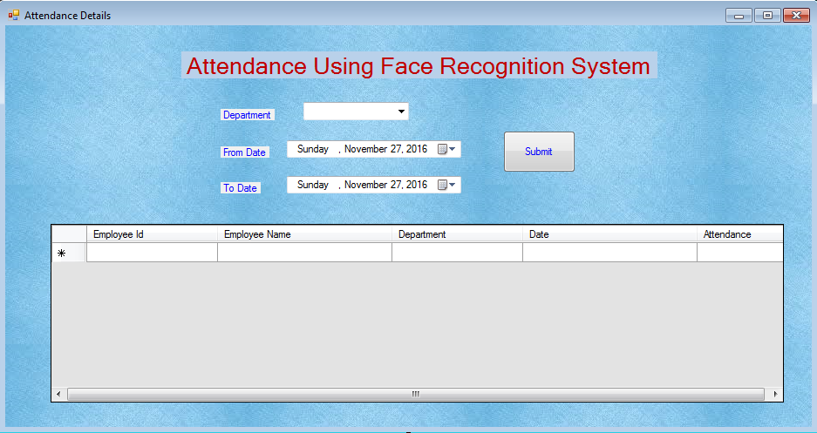
Fig.18
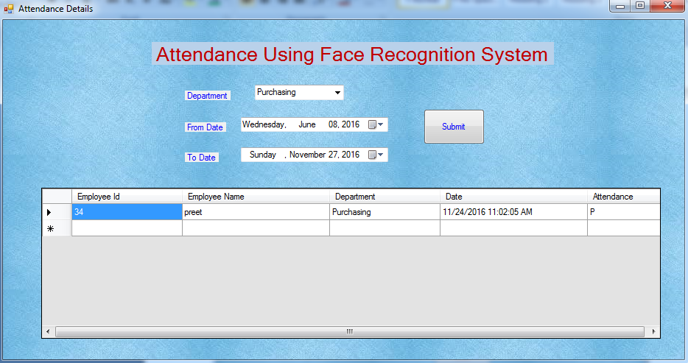

Fig.19

  - Data Design (Database, data file etc.)

Employee Master table

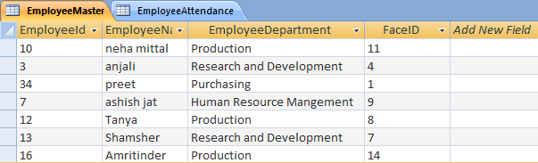
Fig.20

Employee Attendance table

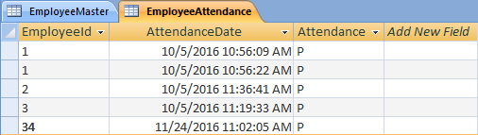
Fig.21
  - Component diagram

Fig.22
3.5 Deployment diagram

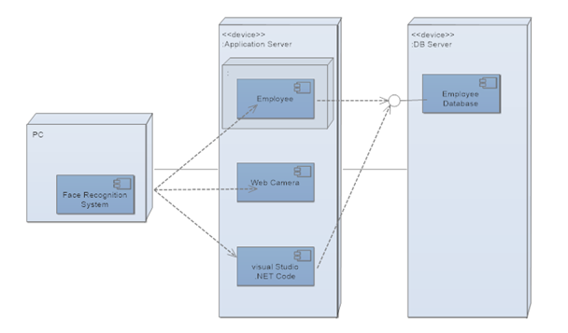
Fig.23

3.6 Software Design Specification
3.6.1 Introduction
The Software Design Specification (SDS) document will have two major functions:
- It focuses on specifying a high-level view of the architecture of our system, and on the interaction between the user and the system.
- It focuses on detailing a low-level view of each component of the software and how the components interact with each other.
This document's purpose is to provide a design framework around which to build our project E-attendance system. It also provides a list of requirements against which to test the final project and determine whether we were able to successfully implement the system according to design.
- Goals and objectives
This document objective is to include system overview, design considerations, architectural strategies, system architecture, policies and tactics, and detailed system design for developer.
The goal of the project is to automate the method of attendance in companies that can replace the old manual methods.
The objectives of the system are:
- Creating a database that contains attendance information of the employees.
- Capturing live feed from camera to record attendance time.
- Linking information about attendance feed to database.

- Statement of scope
In this attendance automation system the attendance of employees will be taken by using face recognition. In system the face details of all employees will be stored in database. During attendance the face will be recognized and attendance will be taken and recorded in database.

- Software context
The overall context of the overall development of the “Attendance using face recognition” system is to automate the attendance taking process in the companies. The attendance automation system will be used in the companies to reduce the manual work in taking attendance of employees.

- Major constraints
The only major constraint to consider in the design of this project is within the algorithm being used for the face detection of the employees in the development of attendance system. We will be using PCA(Principal Component Analysis) algorithm to do multiple comparisons and matches between a face detected and the images stored in binary database. We will be using OpenCV image processing library. Our system is only limited by the rendering constraints of this library.

3.6.2 Data design
The various data structures that are used internally, globally and temporarily are as follows:

1) Internal software data structure
Internal data structure for E-attendance project will include Matrix as a 2D array which will be used for eigen values and eigen vectors .

2) Global data structure
The global data structure for E-attendance project will include Emgu.CV library used in C# .Net.

3) Temporary data structure
No temporary data structure present in E-attendance project.

4) Database description
Database tables for E-attendance project are:

  - Create table Employee( Emp_id varchar(20), dept varchar(30), name string(20), photo image);

Emp_id | Dept | Name | Photo
Table.2

  - Create table Employee_Attendance( Emp_id varchar(20), attendance_date varchar(30), attendance char(10));

Emp_id | Attendance_date | Attendance
Table.3

3.6.3 Architectural and component-level design
Detailed system architecture is shown in the diagram below. Basic phases of our system are:
- Image input of employee
- Face detection
- Face recognition
- Feature Comparison
- Attendance database

1) Program Structure
A detailed description the program structure chosen for the application is presented below:

i) Architecture diagram

Data Flow architecture:

Fig.24

ii)Client-Server architecture:

Fig.25

2) Alternatives

Layered architecture:

Fig.26

System architecture describes the various tiers of system (Data, Logic, Presentation).

The data tier describes the unmodified data contained within the system which in our system was developed with MS Access.
The Logic tier represents the use of data to make the system work and feed the system with the necessary data needed to work. These include the attendance marking, enrolling new employees. This was achieved using C# and an open source library Emgu.CV.
The Presentation tier refers to the specific view a user want to see. Visual Studio Form Application helps us to design this presentation.

The end-to-end traceability of data flows through Layered architecture is a challenging task which becomes more important when systems increase in complexity. So for our project we will go for Data Flow architecture.

3) Description for Component “image input”
Image input of employee will be taken from camera. This image will consist of employee face who come to mark attendance.

3.1 Processing narrative (PSPEC) for component “image input”
A processing narrative for component “image input” is presented below:

Process1: | Image input
Input: | Image captured from the camera
Process: | As employee faces the camera, his/her image will be captured.
Output: | The image captured will be saved and will act as input to the face  detection module.
Table.4

3.2 Component “image input” interface description.
In Input image captured will be taken through imagebox. This image captured will be output to the face detection module.

3.3 Description for Component “face detection”
In face detection we will be using EmguCV cross platform .Net wrapper to the Intel OpenCV image processing library and C# .Net, these library’s allow to capture and process image of a capture device in real time.

3.4 Processing narrative (PSPEC) for component “face detection”
A processing narrative for component “face detection” is presented below:

Process1: | Face detection
Input: | Faces saved in database will be taken as input
Process: | The faces will be transformed into a small set of essential characteristics, eigenfaces ,which are the main components of the initial set of learning images(training set).
Output: | The training set of faces will act as output. The faces detected will be added in the image database with one label respectively.
Table.5

3.4.1 Component “face recognition” interface description.
Input will be human face taken from database. The faces detected will be added in the image database with one label respectively.

3.4.2 Description for Component “face recognition”
One of the simplest and most effective PCA approaches used in face recognition systems is the so-called eigenface approach. A simple approach to extracting the information content in an image of a face is to somehow capture the variations in a collection of face image.
Process1: | Face recognition
Input: | Employee image who come to mark attendance will be taken as input
Process: | Recognition is done by projecting a new image in the eigenface subspace ,after which the person is classified
Output: | The attendance of employee will be marked.

3.4.3 Processing narrative (PSPEC) for component “face recognition” Table.6
3.4.4 Component “face recognition” interface description.
Input will be new human face captured with high definition camera through image box. The face will be send for comparison with trained dataset.

3.4.5 Sub-Component “feature comparison with trained database” processing detail
Feature comparison will be done with the help of PCA algorithm. In this the calculated features are compared with stored features. Using this algorithm we have to extract the relevant information in a face image, encode it efficiently and compare new face encoding with the trained database.

3.4.6 Interface description
The input will be features of new human face detected. The output will be whether the new face features are matched or not with the stored faces.
3.4.7 Algorithmic model (e.g., PDL)
Algorithm steps followed are:

i)Calculate the set of features based on the input image and eigenfaces by projecting the input image onto each of eigenfaces.
ii)Determine the image is known or unknown by checking to see if the image is sufficiently close to a trained set.

3.4.8 Restrictions/limitations
The trained set of faces must be there to do comparison of new face with the stored faces in the database.
3.4.9 Local data structures
Matrix as a 2D array will be used for eigen values and eigen vectors.
3.4.10 Performance issues
If the expressions of human face are changed it might be not recognized with the help of PCA algorithm.
3.4.11 Design constraints
Eigenvalues and matrix used for features extraction will be the constraint for design of PCA algorithm.
3.5 Software Interface Description
The software's interface(s) to the outside world are described as follow:

3.5.1 External machine interfaces
The camera or webcam will act as external machine interface to capture image of an employee.

3.5.2 External system interfaces
The system will use OpenCV library to detect and process the human faces.

3.5.3 Human interface
Employee registration module and mark attendance module is designed for the software in which employee face will be taken for detection and recognition.

4.0 User interface design
A description of the user interface design of the software is presented below:

4.1 Description of the user interface
In our system we have only two user classes which are as:
- Admin
- Employees

A detailed description of user interface including screen images or prototype is presented below:

4.1.1 Screen images

- Login
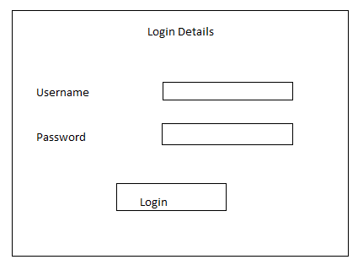
Fig.27

- Employee Registration

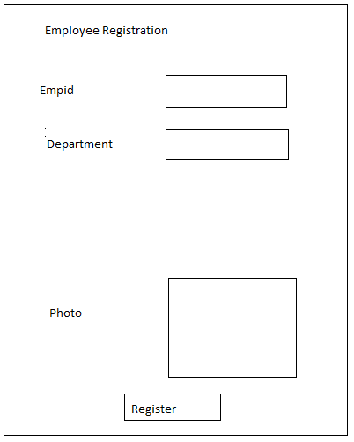
Fig.28

- Update Employee details

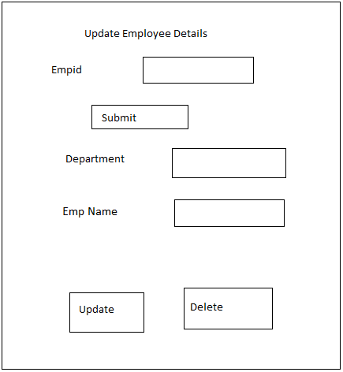

Fig.29

- Mark Employee Attendance

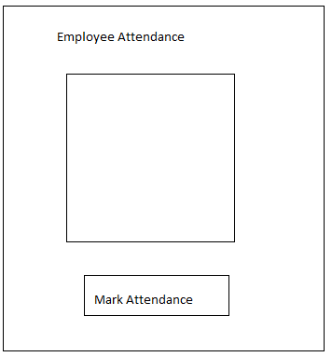

Fig.30

- View Employee Attendance
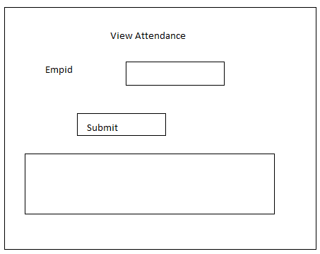

Fig.31

4.1.2 Objects and actions

i) In login screen username and password will be entered by admin. On successful login admin will be redirected to new page.

ii) In Employee registration screen employee-id, department, email-id, phone, photo will be taken from employee to register to this system. On successful registration message showing “employee is registered” will be shown.

iii) In mark attendance screen face of employee will be taken and attendance will be marked.

iv) In view attendance screen employee-id will be entered to view attendance of employee.

4.2 Interface design rules
The user interface will be designed using Forms Application in C# .Net.

4.3 Components available
GUI components like buttons, textboxes, checkboxes, imagebox will be used for designing application forms.

4.4 UIDS description
The user interface will be developed using various components like buttons, textboxes. The interface will be made user friendly by keeping the interface simple. The operations will be performed using buttons.

5.0 Restrictions, limitations, and constraints
In the system the face image will be taken using imagebox in C# .Net. It is difficult to take image clear which can sometime act as limitation to design of system.

6.0 Testing Issues
Test strategy and preliminary test case specification are presented in this section as below:
6.1 Classes of tests
For E-attendance system we will be using Black-box and white-box testing.
Various black-box tests specified are:
- Admin enter incorrect username or password for login.
- Admin enter correct id and password for login.
- Any person who is not registered, his face detected for marking attendance.
- Employee who is registered, his face detected for marking attendance.
- Leave some fields empty in employee registration form.
- Fill all fields in employee registration form.

6.2 Expected software response

 | Test description | Expected Output
i) | Admin enter incorrect username or password for login. | A message must be shown as “incorrect username or password”
ii) | Admin enter correct id and password for login. | The system will be directed to next page.
iii) | Any person who is not registered, his face detected for marking attendance. | A message shown as “face is not recognized”
iv) | Employee who is registered, his face detected for marking attendance. | The attendance will be marked for employee.
v) | Leave some fields empty in employee registration form. | A message must be shown as “fill all the fields”
vi) | Fill all fields in employee registration form. | A message must be shown as “employee is registered successfully”

Table.8

6.3 Performance bounds
In the system form should be redirected to next form immediately. The buttons should respond fast. The user interface components should respond quickly and correctly.

  - Identification of critical components
The critical components which demand particular attention during testing are Image detection, Registration Textboxes , Mark attendance button, Login button.

7.0 Appendices
It Presents information that supplements the design specification.

7.1 Requirements traceability matrix
A matrix that traces stated components and data structures to software requirements is developed.
7.2 Packaging and installation issues

Various installation issues during installation of visual studio are:
- Installation cache is corrupted.
- SQL packages may fail when the local administrator account does not have certain rights.
- Error code occurs when you setup visual studio.

7.3 Design metrics to be used

Various design metrics used to indicate the complexity, quality of the software design are:

- Architectural design metrics:
In architectural design metrics, three software design complexity measures are defined:
- Structural complexity
- Data complexity
- System complexity

- Component-level design metrics:
- Cohesion metrics: Cohesiveness of a module can be indicated by data slice, data tokens, glue tokens.
- Coupling Metrics: This metric indicates the degree to which a module is connected to other modules, global data and the outside environment.
- Complexity Metrics: One of the most widely used complexity metrics for ascertaining the complexity of the program is “ Cyclomatic Complexity”.

- Metrics for object-oriented design:
- Complexity: Determined by assessing how classes are related to each other
- Coupling: Defined as the physical connection between OO design elements
- Sufficiency: Defined as the degree to which an abstraction possesses the features required of it
- Cohesion: Determined by analyzing the degree to which a set of properties that the class possesses is part of the problem domain or design domain
- Primitiveness: Indicates the degree to which the operation is atomic.
Chapter4. Testing

4.1 Test Plan

- Test Plan Identifier
- References
- Introduction
- Test Items
- Software Risk Issues
- Features to be Tested
- Features not to be Tested
- Approach
- Item Pass/Fail Criteria
- Test Deliverables
- Environmental Needs
- Responsibilities

1 TEST PLAN IDENTIFIER
FRS 1.0

2 REFERENCES

Documents that can be referenced include:

- Software Requirements Specifications.
- Software Design Specification.

3 INTRODUCTION

The Software Test Plan (STP) is designed to prescribe the scope, approach, resources, and schedule of all testing activities. The plan must identify the items to be tested, the features to be tested, the types of testing to be performed, the personnel responsible for testing, the resources and schedule required to complete testing, and the risks associated with the plan.
The test plan describes the unit, integration and system tests that will be conducted on the Face Recognition System following integration of the subsystems and component identified. Unit testing provides thorough black box testing, extensive coverage of source code and testing of all module interfaces.

The interfaces between the following subsystems will be tested:
- Employee Registration
- Face Recognition System
- Attendance Marking

The external interfaces to the following devices will be tested:
- Local PC
- Webcamera
The most critical performance measures to test are:
  - The face recognition algorithm (Principal Component Analysis) working.
  - Minimum time to access the Face Recognition System when database is large.

4 TEST ITEMS (FUNCTIONS)
The listing below identifies those items that have been identified as targets for testing. This list represents what will be tested.

4.1 Unit Testing

The modules to be tested as are:
- Admin Login Module
- Employee Registration Module
- Update Employee Module
- Mark Attendance Module
- View Attendance Module

4.2 Integration Testing
In integration testing individual software modules are combined and tested as a group.
- The integration of system (Face Recognition System) modules with package Emgu CV (image processing library) is tested.
- The mark attendance module shall interface with the employee registration module.
- The view attendance module shall interface with the mark attendance module.
- The admin module shall interface with employee registration module, update employee module, mark attendance module, view attendance module.

4.3 System Testing

Functional Testing
- The Face recognition system shall interface with the Database System.
- The System shall operate on Company Server and shall run under Windows Operating System.
- The recognition component of system shall interface with the face recognition algorithm( Principal Component Analysis) algorithm.

Performance testing
- Evaluate execution time for face recognition algorithm.
- Acceptable response time of the system with large database.
Validation Testing
- The Face recognition system must be able to do employee registration.
- The system must be able to mark attendance of employees in company by face recognition.
- The system must be able to show the attendance of employees by retrieving from database.
- The system must be able to take attendance with date and time.

5 SOFTWARE RISK ISSUES

- In the project face recognition algorithm (Principal Component analysis) is used. So project face recognition module will be dependent on the accuracy of algorithm.

- In the project webcamera correct working is mandatory for face recognition.

- In future, version of Emgu CV package may become incompatible with future devices.

6 FEATURES TO BE TESTED

- Admin login with id and password is tested.
- Employee registration with face capturing is tested.
- Attendance marking of registered employees is tested.
- Update employee details feature is tested.
- Viewing employee attendance with date and time is tested.

7 FEATURES NOT TO BE TESTED

The features not to be tested are:
- Maintaining the employee records in the database .We are not testing system for multi user environment.
- Not doing hardware testing.

8 APPROACH (STRATEGY)

Testing approaches used are:

- Black Box testing
In black box testing GUI testing is done.
In black box testing Boundary value analysis and Equivalence class partitioning is also done.

- White Box testing

In this cyclomatic complexity is used to generate test cases.

9 ITEM PASS/FAIL CRITERIA

- The software requirement specification document fulfill pass criteria according to the requirements of the project.
- The software design document fulfill pass criteria according to the project requirements.
- All the test cases are completed at the unit test level.

10 TEST DELIVERABLES

- Test plan document.
- Test report

- ENVIRONMENTAL NEEDS

- The system with webcamera is required in the project.
- Visual Studio with Emgu CV is must be there for project execution.
- Power for system is required.

12 RESPONSIBILITIES

This issue includes all areas of the plan. Here are some examples:
Parampreet Kaur- Perform white-box testing and prepare test cases.
Ashish Gour- Perform black-box testing and prepare test report

4.2 Test Report

Test Case Report

- Admin Login Module

Test type | Test Id | Test Task description | Expected Output | Actual Output | Result
White Box | 1.1 | Admin enter incorrect username or password for login. | A message must be shown as “incorrect username or password” | A message shown as “incorrect username or password” | Pass
White Box | 1.2 | Admin enter correct id and password for login. | The admin must be successfully logged in. | The admin successfully logged in. | Pass
Black Box | 1.3 | Admin enter id and password in login form and click on login button. | The system must be directed to page having links: “Register new employee”, “Update employee”. | The system directed to page having links: “Register new employee”, “Update employee”. | Pass

Table. 9

- Employee Registration Module

Test type | Test Id | Test Task description | Expected Output | Actual output | Result
White Box | 2.1 | Leave employee –id field empty in employee registration form. | A message must be shown as “enter valid employee-id” | A message shown as “enter valid employee-id” | Pass
White Box | 2.2 | Enter alphabets in emp-id field | A message must be shown as “enter valid employee-id” | A message shown as “enter valid employee-id” | Pass
White Box | 2.3 | Leave emp-name field empty | A message must be shown as “enter valid employee name” | A message shown as “enter valid employee name” | Pass
White Box | 2.4 | Enter digits in emp-name field | A message must be shown as “enter valid employee name” | A message shown as “enter valid employee name” | Pass
White Box | 2.5 | Do not select department from combo-box | A message must be shown as “please select department from combo box” | A message shown as “please select department from combo | Pass
White Box | 2.6 | Enter valid Emp-id, Emp-name and select department from combo Box | Employee registration is successful | Employee registration is successful | Pass
Black Box | 2.7 | Fill complete details in registration form and submit it. | The employee is registered and details added in the database. | The employee is registered and details added in the database. | Pass
Table.10

- Update Employee Module

Test type | Test Id | Test Task description | Expected Output | Actual Output | Result
White Box | 3.1 | Do not change any field in update employee form. | A message must be shown as “No changes have been made” | A message shown as “No changes have been made” | Pass
White Box | 3.2 | Change some fields in update employee form. | A message must be shown as “Successfully updated” | A message shown as “Successfully updated” | Pass
Black Box | 3.3 | Fill complete details in update employee form and submit it. | The employee details are updated in the database. | The employee name is not updated in the database. | Fail
Table.11

- Mark Attendance Module
Test type | Test Id | Test Task description | Expected Output | Actual output | Result
White Box | 4.1 | Any person who is not registered, his face detected for marking attendance. | A message shown as “face is not recognized” | A message shown as “face is not recognized” | Pass
White Box | 4.2 | Employee who is registered, his face detected for marking attendance. | The attendance will be marked for employee. | The attendance will be marked for employee | Pass
Table.12
- View Attendance Module

Test type | Test Id | Test Task description | Expected Output | Actual output | Results
White Box | 5.1 | Do not Select department from combo-box | A message shown as “select department from combo box” | A message shown as’’ select department from combo box” | Pass
White Box | 5.2 | Select department from combo-box | The employee attendance will be shown. | The employee attendance will be shown. | Pass
Table.13

WHITE-BOX TESTING
1.Mark attendance Module:

- try (trainingImages.ToArray().Length != 0)
{
- MCvTermCriteria termCrit = new MCvTermCriteria(16, 0.001);
- EigenObjectRecognizer recognizer = new EigenObjectRecognizer( trainingImages.ToArray(), labels.ToArray(),3000,ref termCrit);
- name = recognizer.Recognize(result);
- currentFrame.Draw(name, ref font, new Point(f.rect.X - 2, f.rect.Y - 2), new Bgr(Color.LightGreen));
}
- catch (Exception e)
{
- MessageBox.Show("Face not recognised", MessageBoxButtons.OK, MessageBoxIcon.Exclamation);
- }}

1
Flow Graph:
false
true
2
3
Paths:
Path1: 1- 3 – 4- 8
8
4
Path2: 1- 2- 8
Fig.32

Block No | Line No
1 | 1
2 | 2,3,4,5
3 | 6
4 | 7
8 | 8
2.Employee Registration Module

- private void button3_Click_1(object sender, EventArgs e)
{
- if (System.Text.RegularExpressions.Regex.IsMatch(txtEnrNo.Text, "^[a-zA-Z]") ||
- txtEnrNo.Text ==string.Empty)
{
- MessageBox.Show("Please enter valid employee id!");
- return;
}
- else if (System.Text.RegularExpressions.Regex.IsMatch(txtStuName.Text, "^[0-9]") ||
- txtStuName.Text == string.Empty)
{
- MessageBox.Show("Please enter valid employee name!");
}
- else if (cbClass.SelectedIndex == -1)
{
- MessageBox.Show("Please select department from comboBox!");
}

- else
{

- grabber = new Capture();
- grabber.QueryFrame();
- }
- }

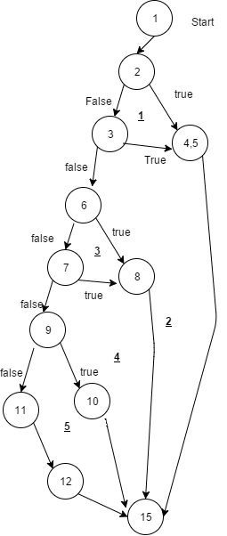
Flow Graph
Fig.33

Cyclomatic Complexity:
Complexity = E-N+2
=17-13+2
= 6

Paths:
Path 1: 1- 2a - 3, 4 – 15
Path2: 1- 2a – 2b - 3 – 15
Path3: 1- 2a – 2b – 5a – 6 - 15
Path4: 1- 2a – 2b – 5a – 5b – 6 - 15
Path5: 1- 2a – 2b – 5a – 7 – 8 - 15
Path6: 1- 2a – 2b – 5a – 7 – 9 – 10-14 - 15

GENERAL INFORMATION
Test Stage: | GUI testing
Test Date: | 15/11/16 | System Date, if applicable: | 15/11/16
Tester: | Ashish Gour | Test Case Number: | 6
Test Case Description: | GUI is a hierarchical, graphical front end to the application, contains graphical objects with a set of properties
Results: | Pass
INTRODUCTION
Requirement(s) to be tested: | Check all like label, buttons, text boxes, and all types of bars - menu bar, dialog boxes.
Roles and Responsibilities: | Ashish Gour- Check all the buttons icons properly work or not  Check Font used in application is readable  Check the alignment of the text is proper
TEST
Test Items/Features: | Label , buttons, text boxes, and all types of bars -menu bar, dialog boxes
Input Specifications: | Click and check all the test items.
Expected Results of Case: | All test item should work properly
ACTUAL RESULTS
Output Specifications: | The test case has passed status as all test items behave as the desired output.
Table.14

BLACK-BOX TESTING
Equivalence Class Partitioning:
In this method the input domain data is divided into different equivalence data classes.
Test cases for text box (Employee-id) accepting numbers between 1 and 100 using Equivalence Partitioning:
1) One input data class with all valid inputs. Pick a single value from range 1 to 100 as a valid test case. If you select other values between 1 and 100 then result is going to be same. So one test case for valid input data should be sufficient.
Set:{1<value<100} valid class

2) Input data class with all values below lower limit. i.e. any value below 1, as an invalid input data test case.
Set:{value<1} invalid class
3) Input data with any value greater than 100 to represent third invalid input class.
Set:{value>100} invalid class

Test type | Test Id | Test Task description | Expected Output | Actual Output | Result
Black Box | 6.1 | Enter “50”value in employee-id field. | The employee should be successfully registered. | The employee is successfully registered. | Pass
Black Box | 6.2 | Enter “-4” value in employee-id field. | A message must be shown as “you have to enter employee-id between 1 and 100” | A message shown as “you have to enter employee-id between 1 and 100” | Pass
Black Box | 6.3 | Enter “400” value in employee-id field. | A message must be shown as “you have to enter employee-id between 1 and 100” | A message shown as “you have to enter employee-id between 1 and 100” | Pass
Table.15

Boundary Value Analysis
Boundary value analysis testing technique is used to identify errors at boundaries rather than finding those exist in center of input domain.
Test cases for text box (employee-id) accepting numbers between 1 and 100 using Boundary value analysis:
1) Test cases with test data exactly as the input boundaries of input domain i.e. values 1 and 100 in our case.
2) Test data with values just below the extreme edges of input domains i.e. values 0 and 99.
3) Test data with values just above the extreme edges of input domain i.e. values 2 and 101.

Test type | Test Id | Test Task description | Expected Output | Actual Output | Result
Black Box | 7.1 | Enter “1” value in employee-id field. | The employee should be successfully registered. | The employee is successfully registered. | Pass
Black Box | 7.2 | Enter “100” value in employee-id field. | The employee should be successfully registered | The employee is successfully registered. | Pass
Black Box | 7.3 | Enter “0” value in employee-id field. | A message must be shown as “you have to enter employee-id between 1 and 100” | A message shown as “you have to enter employee-id between 1 and 100” | Pass
Black Box | 7.4 | Enter “99” value in employee-id field. | The employee should be successfully registered | The employee is successfully registered. | Pass
Black Box | 7.5 | Enter “2” value in employee-id field. | The employee should be successfully registered | The employee is successfully registered. | Pass
Black Box | 7.6 | Enter “101” value in employee-id field. | A message must be shown as “you have to enter employee-id between 1 and 100” | A message shown as “you have to enter employee-id between 1 and 100” | Pass

